**Employee Management Rest API Screenshots**

1. **Adding roles in the database**

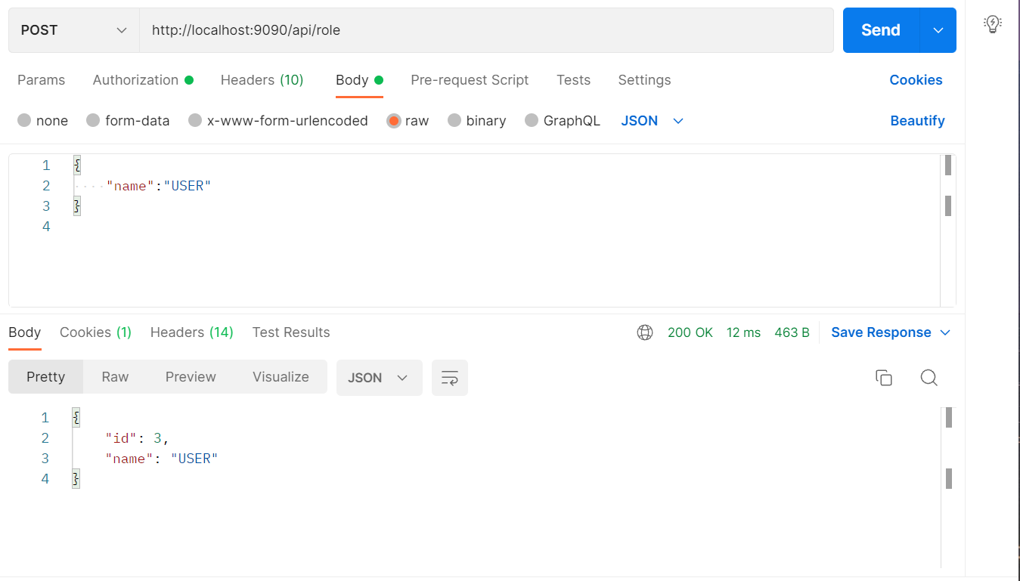

1. **Adding Users which can be used for authentication purposes**

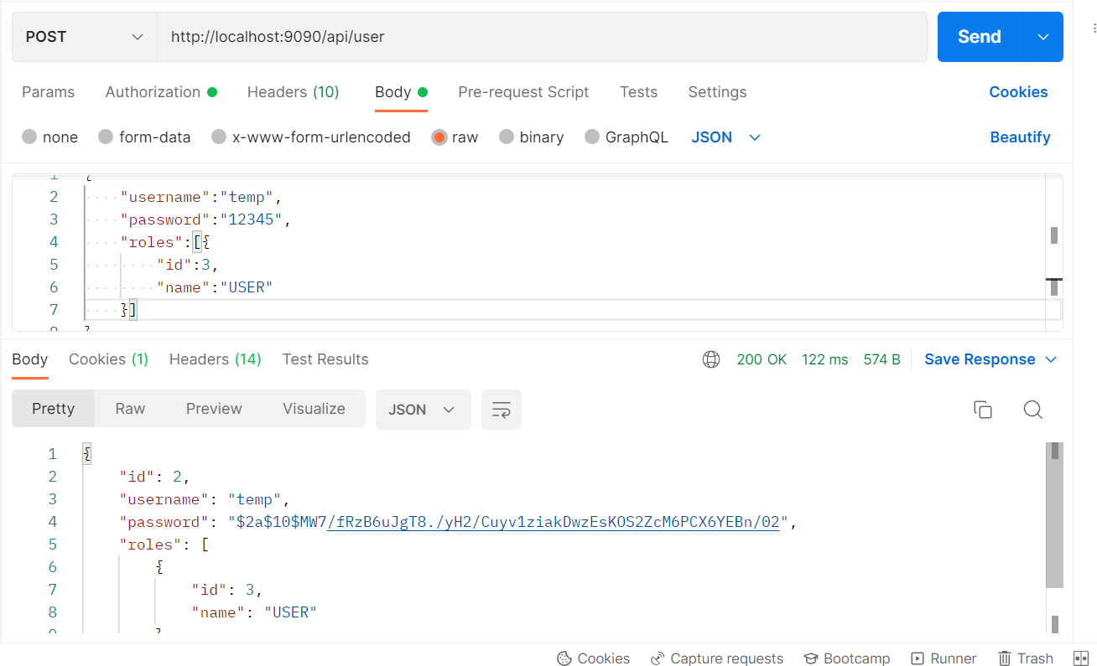

1. **Adding employee’s data to database only if the authenticated user is ADMIN**

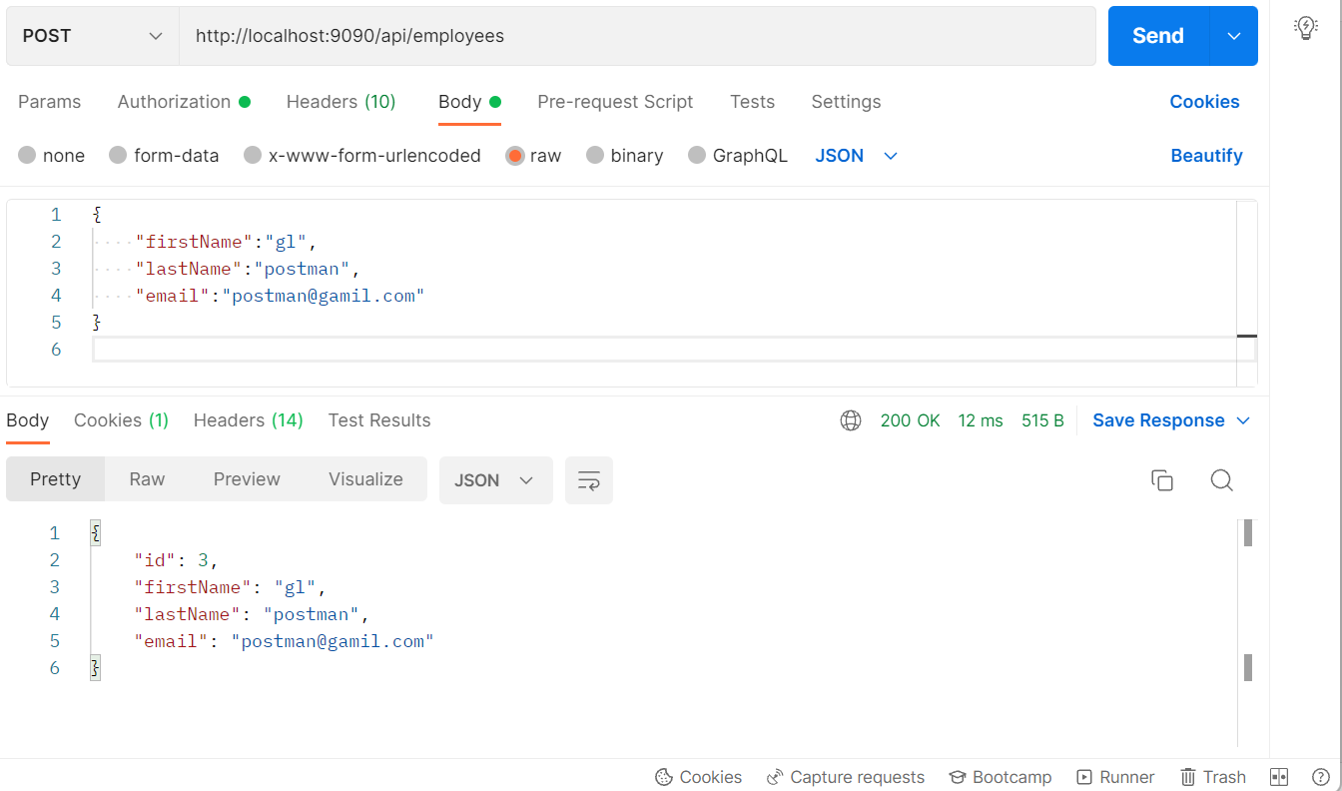

**As USER , the response is as below:**

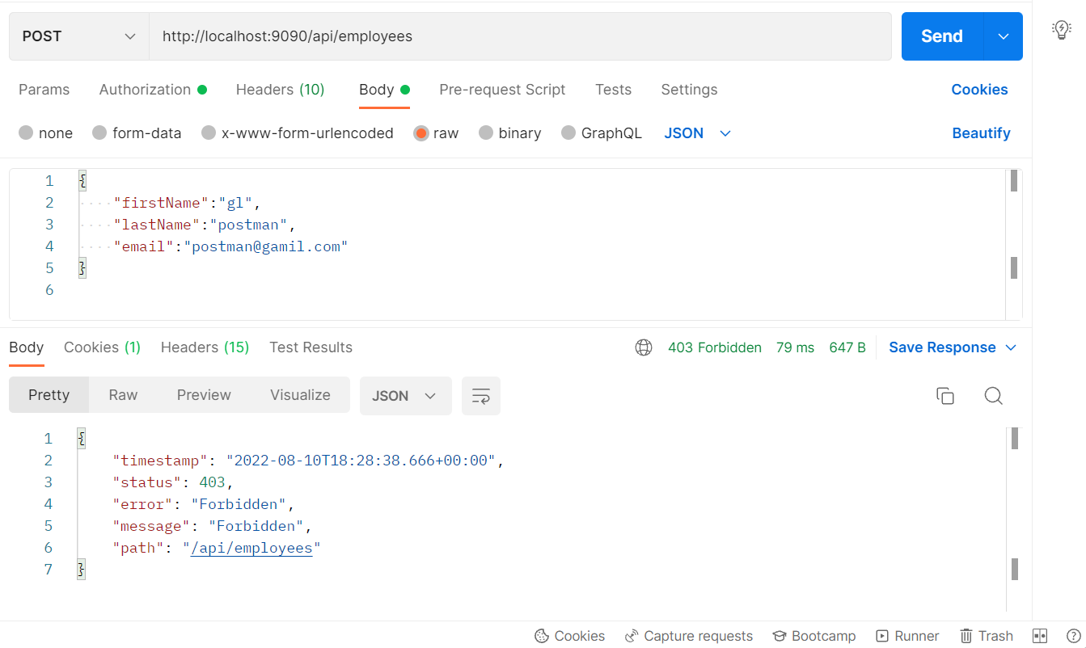

1. **List all the employees stored in the database**

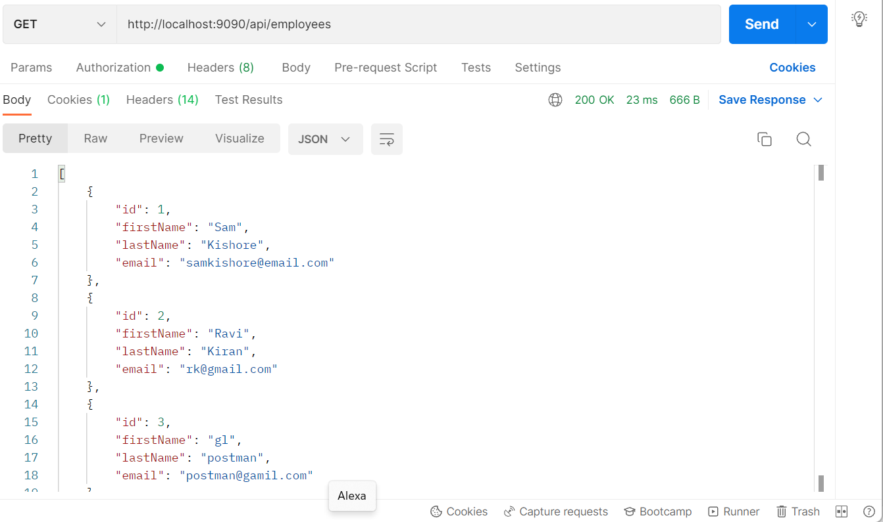

1. **Get employee record by employee id**

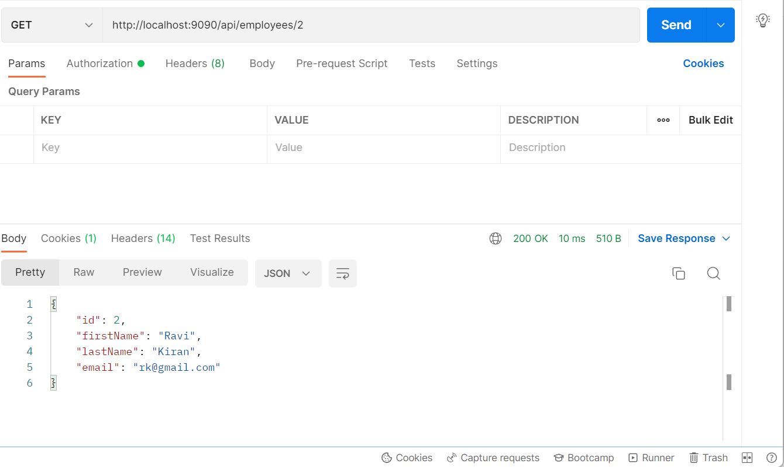

1. **Update an existing employee record**

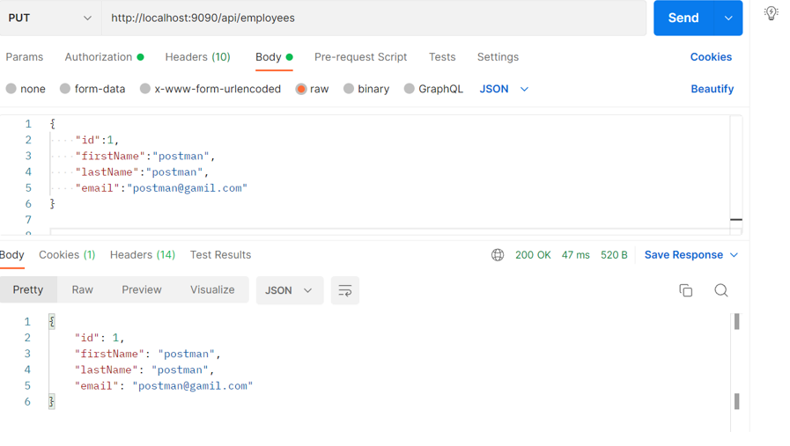

1. **Delete an existing employee record**

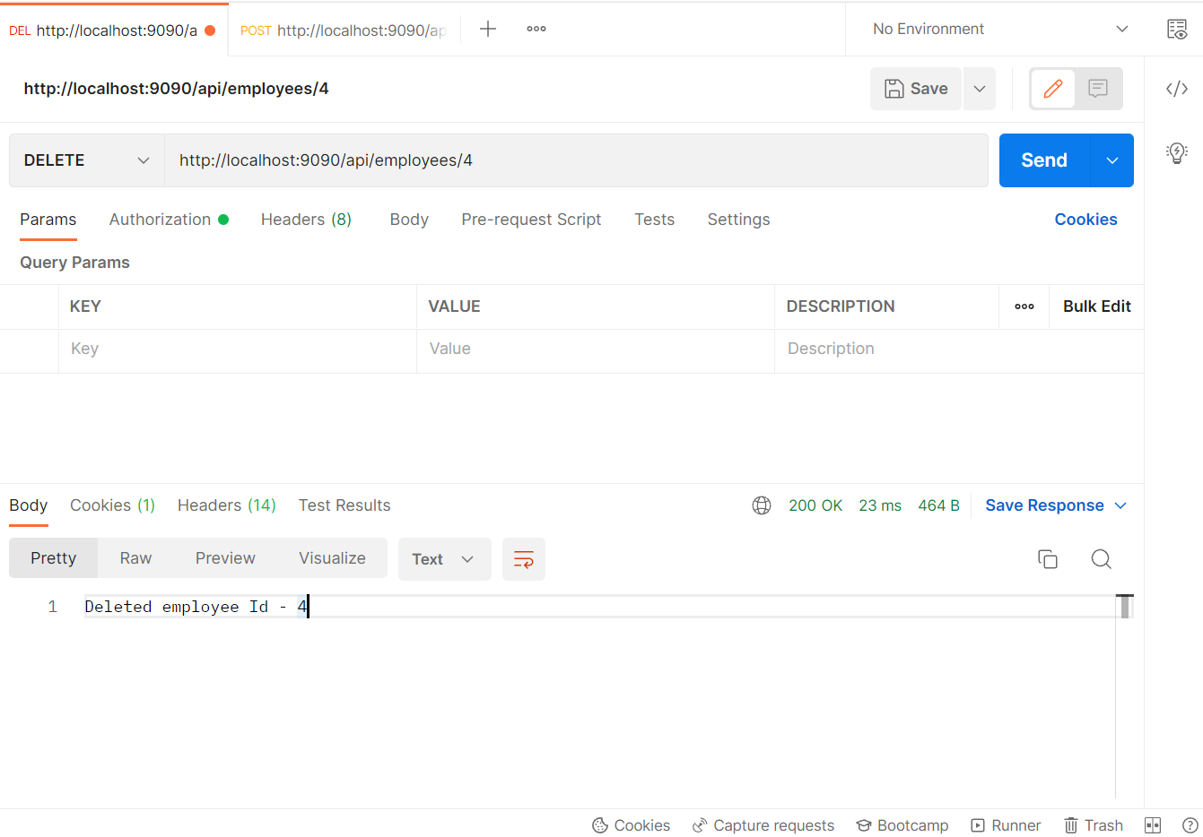

1. **Fetch an employee by first name**

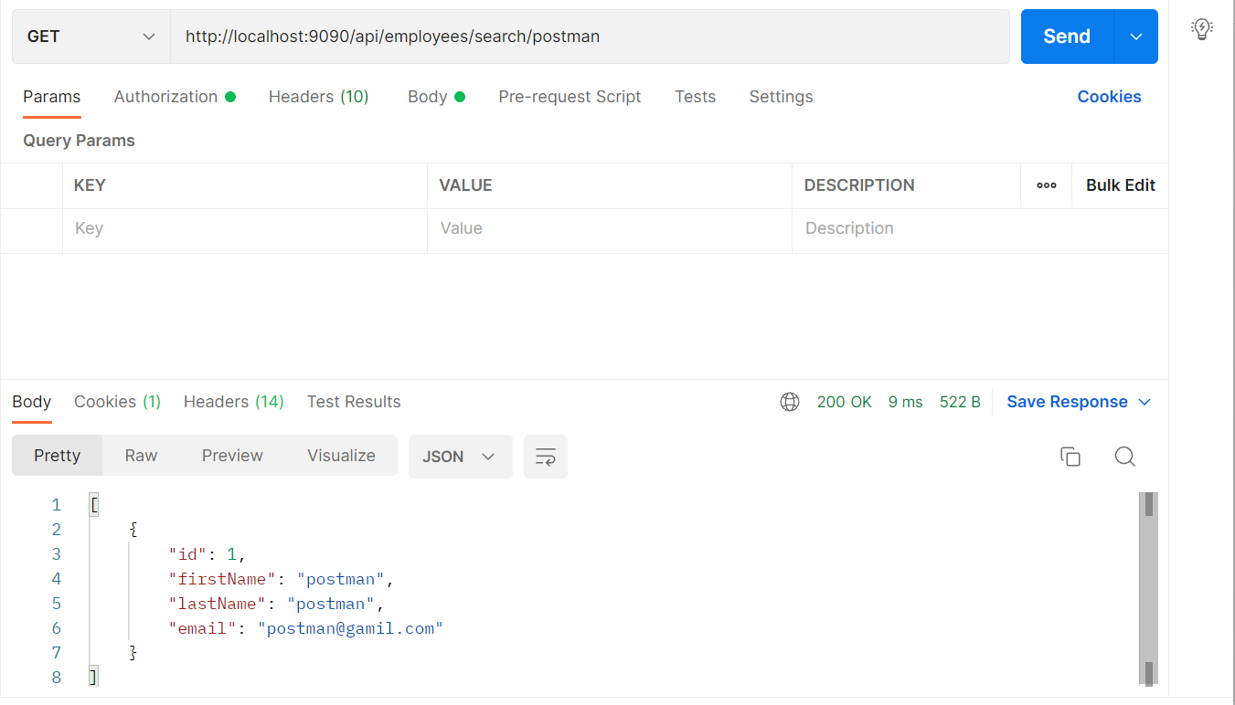

1. **List all employee records sorted on their first name in either ascending order or descending order**

**Ascending:**

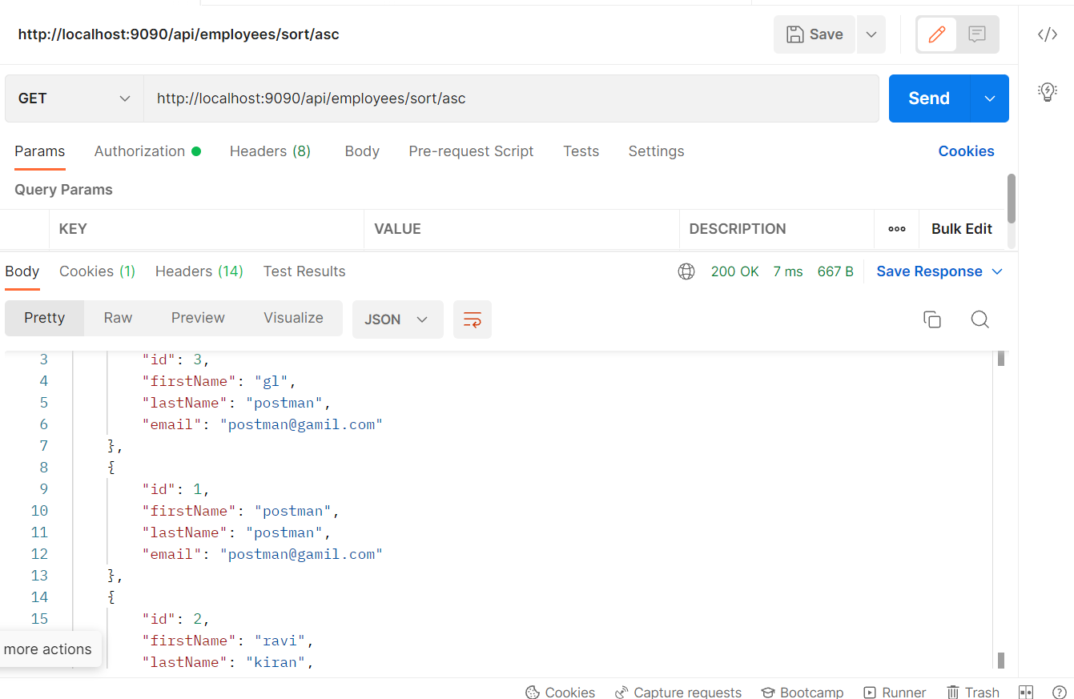

**Descending:**

